Job Order - Expenses

- Purpose

Once the job order on a repossessed MC unit has been completed, the Receptionist will now encode the Job Order Expenses to keep track of the actual expenses and update the product cost.

- Views
  - List View
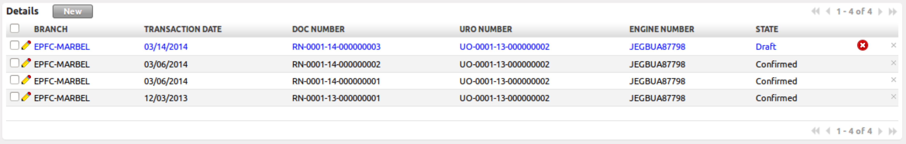
Figure 1. List view of Job Order Expenses

  - Form View
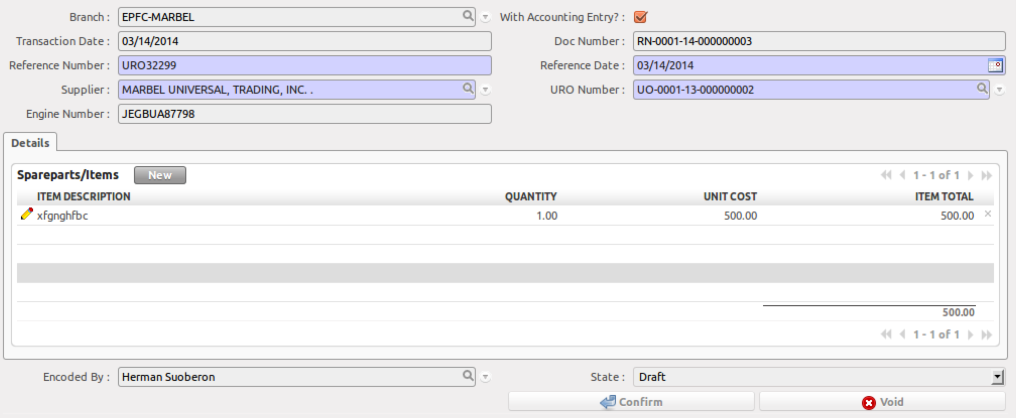
Figure 2. Form view of Job Order Expenses

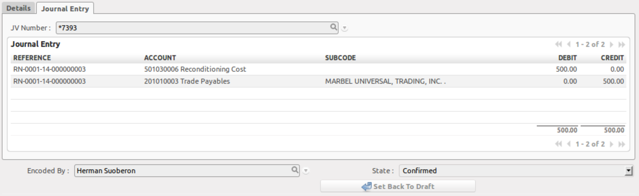
Figure 3. Journal Entry tab of Job Order Expenses

- Menu and Access Rights
  - Menu – Job Order > Expenses
  - Access Rights
Role | Read | Write | Create | Delete
Receptionist | Yes | Yes | Yes | No
Branch Accounting Assistant | Yes | Yes | No | No
Branch Manager | Yes | No | No | No

- Required Fields
All required fields can be easily distinguished from the form view. These are the fields highlighted in Figure 2.

- Reference Number –
- Reference Date –
- Supplier –
- Job Order No. -

- Workflow
Below is the list of states and visibility of the various buttons based on the record state:

Figure 5. Workflow of Job Order Expenses

State | Description | Visible Buttons
Draft | Initial state of the record | Confirm
Confirmed | Record has been submitted for review and no further changes is expected. | Recommend

- User Action
Below is the list of user action available for specific users and its corresponding procedures:

Button | Action | Triggred By
Confirm | This will create journal entries | Branch Accounting Assistant

- Field Visibility
All fields are visible to all users with read access to the record.

- Reports and Print Outs


